**Test 1. Test 2. Test 3.**

**Biden to nominate** Janet Yellen as US treasury secretary ds

Published

1 hour ago

Share

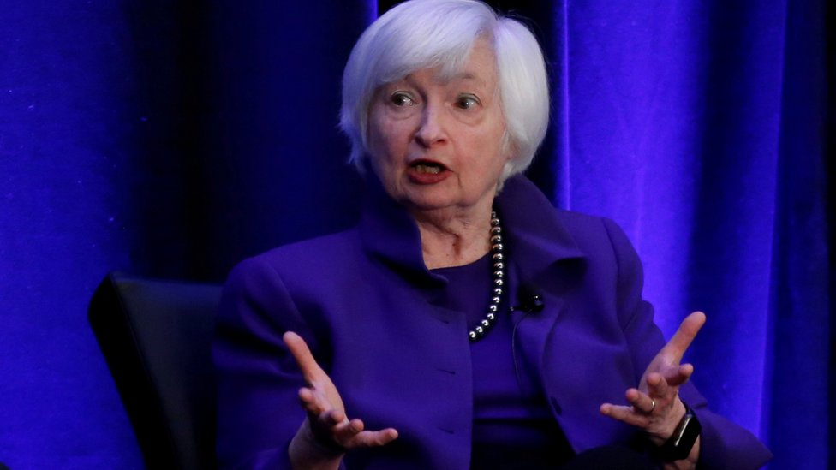IMAGE COPYRIGHTREUTERS 3

image captionJanet Yellen's appointment needs to be confirmed by the Senate

**US President-elect Joe Biden has named ex-Federal Reserve chair Janet Yellen as his nominee for treasury secretary 44444.**

If confirmed by the Senate, she would be the first woman ever to hold the post2. She was among several women chosen for top economic positions2. The Biden transition team said others were set to break racial barriers if confirmed2. Mr Biden has pledged to 33 build a diverse administration 333. He earlier appointed an all 444.

She was among several women chosen for top economic positions244. Dummy text.